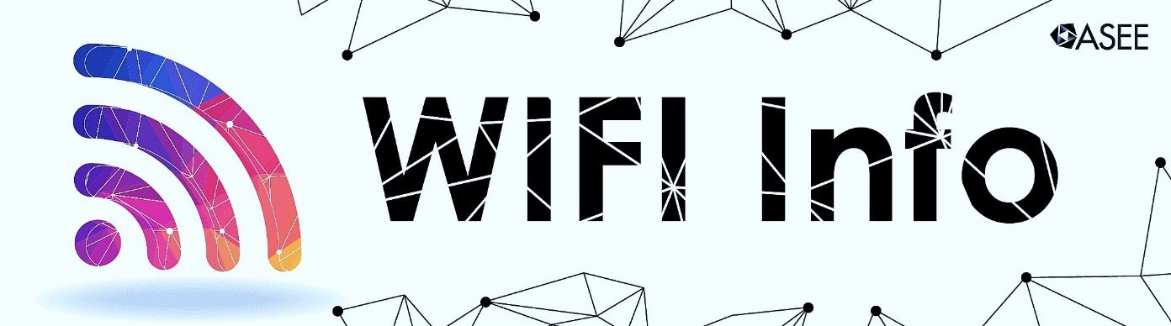

Complimentary Wi-Fi is provided in the Columbus Convention Center meeting rooms and public areas, and in the Hyatt Regency Columbus meeting rooms and lobby. Here’s how to access:

COLUMBUS CONVENTION CENTER

Note: Free wireless Internet is NOT available inside the exhibit halls or ballrooms. It is available for all other public areas including the meeting rooms. Smart City Networks cannot guarantee the functionality of VPN client ASEE.

To access the Free Internet Wireless Service provided by Smart City Networks and the Greater
Columbus Convention Center, please follow these instructions:

1. With a Wi-Fi enabled device find the wireless network named FreeInternet.
2. Connect to the wireless network named FreeInternet
3. Once connected to this network, open up an Internet browser.
4. You should be automatically redirected to the Free Internet splash page, regardless of what homepage your device is set to. *
5. Click on the button that says Continue to Internet and you will be redirected to the Greater Columbus Convention Center website which will complete your connection.

If you have any problems, please contact the helpdesk at (614) 827-2570.

* If you are not automatically redirected, check to see if you have http://about.blank or a corporate Intranet site set as your homepage. If so, navigate your browser to any public site, such as http://www.smartcity.com -- which should redirect you to the Exhibitor Internet splash page.

HYATT REGENCY COLUMBUS

1. Connect to the following wireless network: HyattMR
2. Open your web browser.
This will automatically take you to our login splash page. If not, please type www.psav.com into your address bar and press enter. You should now see the splash page.
If you still cannot reach the splash page, please make sure you are connected to the correct wireless network.
3. Enter the following case-sensitive password: ASEE17

